Vending Machine

Understanding the problem:

* Our goal is to design a vending machine which would return an ice-cream flavor as per the customer’s choice from the given 8 flavors.
* Restriction provided is that customer has only four denominations of money: $1, $5, $10, $20.
* So, generated hardware would be a ‘Finite State Machine’ .

Devising the plan:

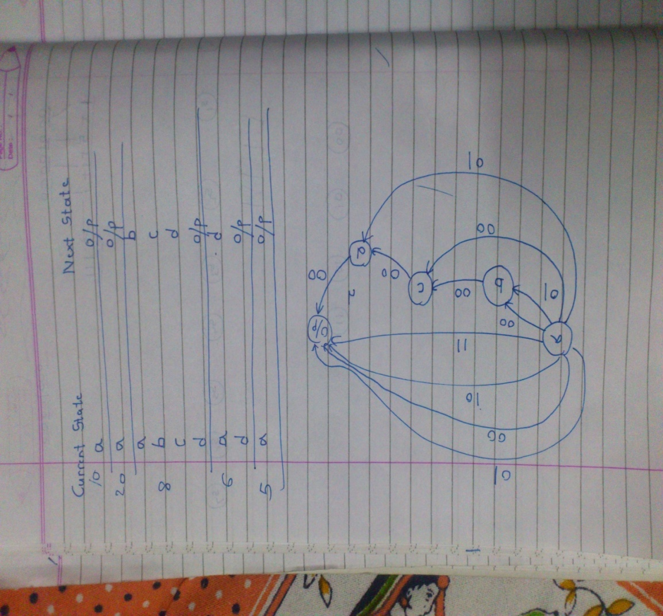

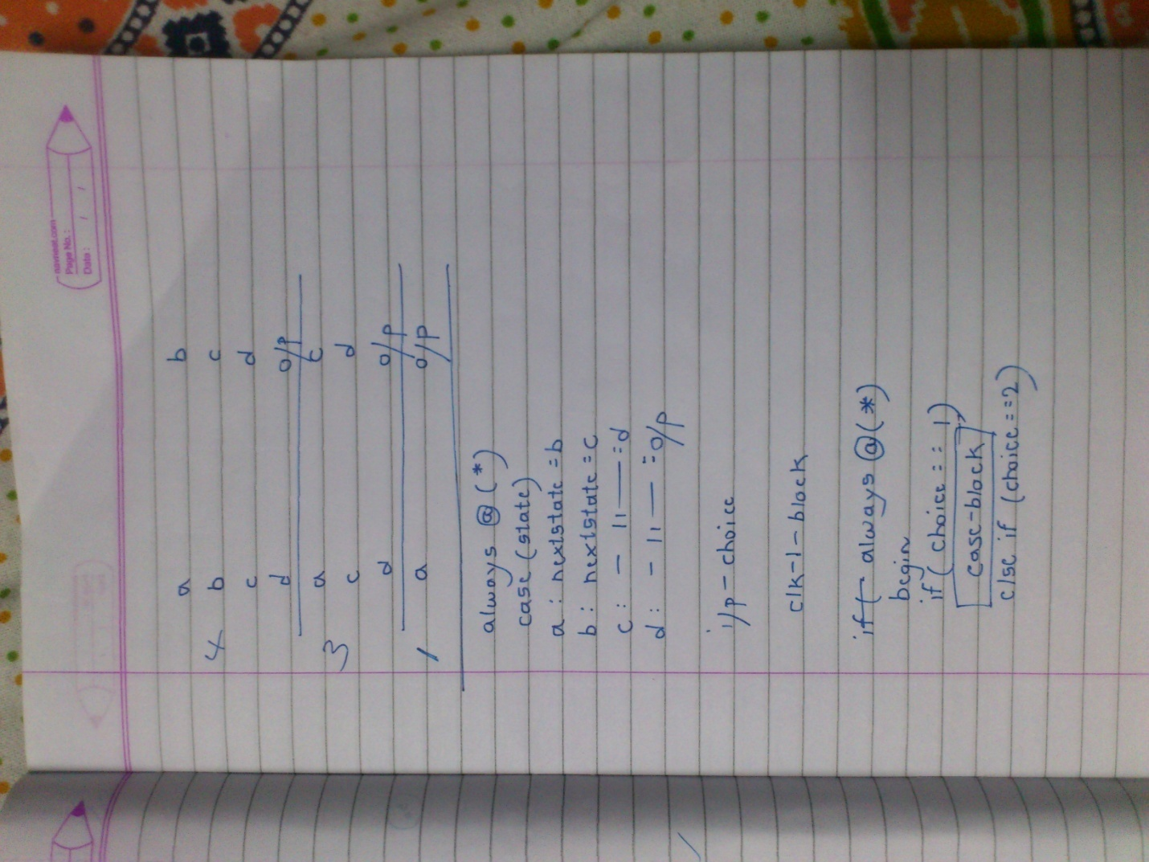

* Before drawing the state diagram, we have suitably assumed that the customer would pay for the flavor in minimum possible combinations of given money denominations.
* For example, if the customer wants to buy ‘chocolate chips’ of $10,he would enter a $10 coin and not two $5 coins or other possible chances.
* As seen in the state diagram, we have 4 distinct states and 1 theoretical output state as maximum transitions possible are 4.
* According to the choice, state transitions will occur from state ‘a’ to ‘o/p’ state.
* These transitions would be unique for each choice.
* We have 5 states. Hence flipflops used must be 3.

|  |  |  |
| --- | --- | --- |
| Flavour | Combination of money | Choice |
| Banana Strawberries | 1 | 000 |
| Black Walnut | 1+1+1 | 001 |
| Rum Raisin | 1+1+1+1 | 010 |
| Caramel Praline Cheesecake | 5 | 011 |
| Chocolate Moose | 5+1 | 100 |
| Super Fudge Truffle | 5+1+1+1 | 101 |
| Chocolate Chips | 10 | 110 |
| Very Berry Strawberry | 20 | 111 |

* For example- for Super Fudge Truffle($8) there are four coins entered 5,1,1,1. Hence four transitions will take place a to b, b to c, c to d, d to op.

Carrying out the plan:

**Verilog code:**

module VM1(

input [2:0] choice,

output [2:0]y,

input clk,

input reset

);

reg[2:0] state,nextstate;

parameter a=3'b000;

parameter b=3'b001;

parameter c=3'b010;

parameter d=3'b011;

parameter op=3'b100;

always @ (posedge clk,posedge reset)

begin

if (reset) state<=a;

else state<= nextstate;

end

always @ (*)

if(choice==3'b000)

begin

case(state)

a: nextstate=op;

default: nextstate=a;

endcase

end

else if(choice==3'b001)

begin

case(state)

a: nextstate=c;

c: nextstate=d;

d: nextstate=op;

default: nextstate=a;

endcase

end

else if(choice==3'b010)

begin

case(state)

a: nextstate=b;

b: nextstate=c;

c: nextstate=d;

d: nextstate=op;

default: nextstate=a;

endcase

end

else if(choice==3'b011)

begin

case(state)

a: nextstate=op;

default: nextstate=a;

endcase

end

else if(choice==3'b100)

begin

case(state)

a: nextstate=d;

d: nextstate=op;

default: nextstate=a;

endcase

end

else if(choice==3'b101)

begin

case(state)

a: nextstate=b;

b: nextstate=c;

c: nextstate=d;

d: nextstate=op;

default: nextstate=a;

endcase

end

else if(choice==3'b110)

begin

case(state)

a: nextstate=op;

default: nextstate=a;

endcase

end

else if(choice==3'b111)

begin

case(state)

a: nextstate=op;

default: nextstate=a;

endcase

end

else nextstate=a;

assign y=state;

endmodule

**RTL Schematic:**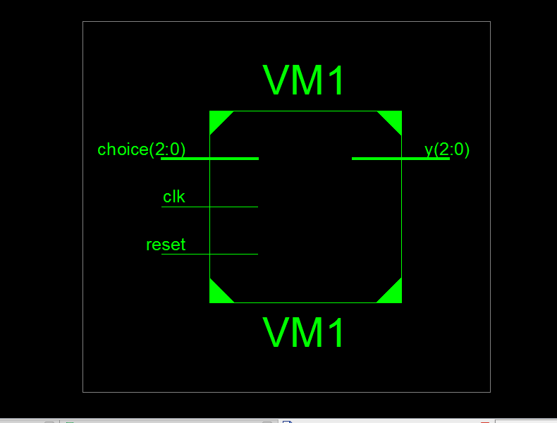

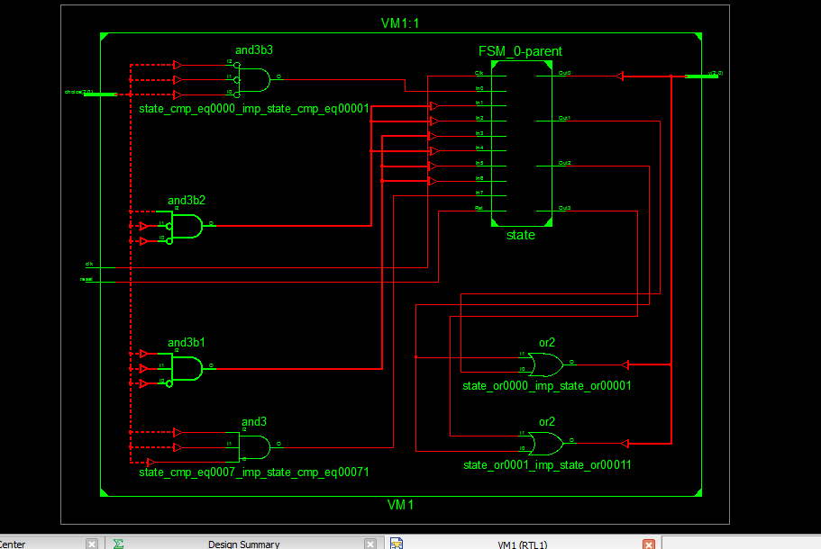

**Test Bench:**

modulefinal_tb;

// Inputs

reg [2:0] choice;

regclk;

reg reset;

// Outputs

wire [2:0] y;

// Instantiate the Unit Under Test (UUT)

VM1 uut (

.choice(choice),

.y(y),

.clk(clk),

.reset(reset)

);

initial begin

// Initialize Inputs

choice = 0;

clk = 0;

reset = 0;

// Wait 100 ns for global reset to finish

#100;

// Add stimulus here

#100;

choice=3'b001;

clk=1'b1;

#10;

clk=1'b0;

#10;

clk=1'b1;

#10;

clk=1'b0;

#10;

clk=1'b1;

#10;

clk=1'b0;

#10;

clk=1'b1;

#10;

clk=1'b0;

#10;

end

endmodule

**Output:**

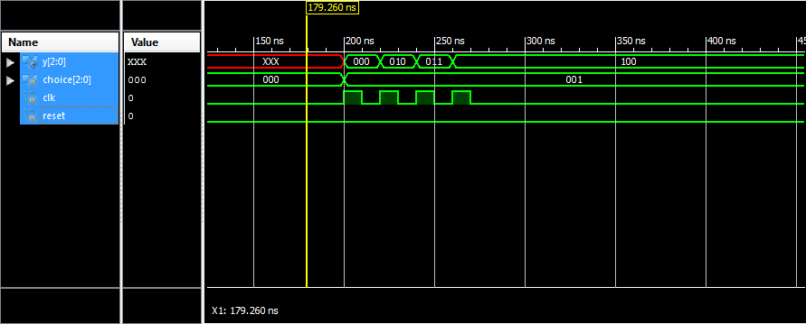

Looking Back:

* We can see that at every positive edge of the clock, state transition occurs.
* For each choice, number of clock pulses required to reach at the output state would differ as it depends on the number of state transitions unique

for that choice.

* As the next state depends on input (choice) as well as current state we have designed a Mealy model.

Synthesis Report:

Release 12.1 - xst M.53d (nt)

Copyright (c) 1995-2010 Xilinx, Inc. All rights reserved.

--> Parameter TMPDIR set to xst/projnav.tmp

Total REAL time to Xst completion: 0.00 secs

Total CPU time to Xst completion: 0.45 secs

--> Parameter xsthdpdir set to xst

Total REAL time to Xst completion: 0.00 secs

Total CPU time to Xst completion: 0.47 secs

--> Reading design: VM1.prj

TABLE OF CONTENTS

1) Synthesis Options Summary

2) HDL Compilation

3) Design Hierarchy Analysis

4) HDL Analysis

5) HDL Synthesis

5.1) HDL Synthesis Report

6) Advanced HDL Synthesis

6.1) Advanced HDL Synthesis Report

7) Low Level Synthesis

8) Partition Report

9) Final Report

9.1) Device utilization summary

9.2) Partition Resource Summary

9.3) TIMING REPORT

=========================================================================

* Synthesis Options Summary *

=========================================================================

---- Source Parameters

Input File Name : "VM1.prj"

Input Format : mixed

Ignore Synthesis Constraint File : NO

---- Target Parameters

Output File Name : "VM1"

Output Format : NGC

Target Device : xc3s200-5-pq208

---- Source Options

Top Module Name : VM1

Automatic FSM Extraction : YES

FSM Encoding Algorithm : Auto

Safe Implementation : No

FSM Style : lut

RAM Extraction : Yes

RAM Style : Auto

ROM Extraction : Yes

Mux Style : Auto

Decoder Extraction : YES

Priority Encoder Extraction : YES

Shift Register Extraction : YES

Logical Shifter Extraction : YES

XOR Collapsing : YES

ROM Style : Auto

Mux Extraction : YES

Resource Sharing : YES

Asynchronous To Synchronous : NO

Multiplier Style : auto

Automatic Register Balancing : No

---- Target Options

Add IO Buffers : YES

Global Maximum Fanout : 500

Add Generic Clock Buffer(BUFG) : 8

Register Duplication : YES

Slice Packing : YES

Optimize Instantiated Primitives : NO

Use Clock Enable : Yes

Use Synchronous Set : Yes

Use Synchronous Reset : Yes

Pack IO Registers into IOBs : auto

Equivalent register Removal : YES

---- General Options

Optimization Goal : Speed

Optimization Effort : 1

Library Search Order : VM1.lso

Keep Hierarchy : NO

Netlist Hierarchy : as_optimized

RTL Output : Yes

Global Optimization : AllClockNets

Read Cores : YES

Write Timing Constraints : NO

Cross Clock Analysis : NO

Hierarchy Separator : /

Bus Delimiter : <>

Case Specifier : maintain

Slice Utilization Ratio : 100

BRAM Utilization Ratio : 100

Verilog 2001 : YES

Auto BRAM Packing : NO

Slice Utilization Ratio Delta : 5

=========================================================================

=========================================================================

* HDL Compilation *

=========================================================================

Compiling verilog file "VM1.v" in library work

Module <VM1> compiled

No errors in compilation

Analysis of file <"VM1.prj"> succeeded.

=========================================================================

* Design Hierarchy Analysis *

=========================================================================

Analyzing hierarchy for module <VM1> in library <work> with parameters.

a = "000"

b = "001"

c = "010"

d = "011"

op = "100"

=========================================================================

* HDL Analysis *

=========================================================================

Analyzing top module <VM1>.

a = 3'b000

b = 3'b001

c = 3'b010

d = 3'b011

op = 3'b100

Module <VM1> is correct for synthesis.

=========================================================================

* HDL Synthesis *

=========================================================================

Performing bidirectional port resolution...

Synthesizing Unit <VM1>.

Related source file is "VM1.v".

Found finite state machine <FSM_0> for signal <state>.

-----------------------------------------------------------------------

| States | 5 |

| Transitions | 33 |

| Inputs | 8 |

| Outputs | 4 |

| Clock | clk (rising_edge) |

| Reset | reset (positive) |

| Reset type | asynchronous |

| Reset State | 000 |

| Encoding | automatic |

| Implementation | LUT |

-----------------------------------------------------------------------

Summary:

inferred 1 Finite State Machine(s).

Unit <VM1> synthesized.

=========================================================================

HDL Synthesis Report

Found no macro

=========================================================================

=========================================================================

* Advanced HDL Synthesis *

=========================================================================

Analyzing FSM <FSM_0> for best encoding.

Optimizing FSM <state/FSM> on signal <state[1:3]> with user encoding.

-------------------

State | Encoding

-------------------

000 | 000

100 | 100

010 | 010

011 | 011

001 | 001

-------------------

=========================================================================

Advanced HDL Synthesis Report

Macro Statistics

# FSMs : 1

=========================================================================

=========================================================================

* Low Level Synthesis *

=========================================================================

Optimizing unit <VM1> ...

Mapping all equations...

Building and optimizing final netlist ...

Found area constraint ratio of 100 (+ 5) on block VM1, actual ratio is 0.

Final Macro Processing ...

=========================================================================

Final Register Report

Macro Statistics

# Registers : 3

Flip-Flops : 3

=========================================================================

=========================================================================

* Partition Report *

=========================================================================

Partition Implementation Status

-------------------------------

No Partitions were found in this design.

-------------------------------

=========================================================================

* Final Report *

=========================================================================

Final Results

RTL Top Level Output File Name : VM1.ngr

Top Level Output File Name : VM1

Output Format : NGC

Optimization Goal : Speed

Keep Hierarchy : NO

Design Statistics

# IOs : 8

Cell Usage :

# BELS : 10

# LUT3 : 1

# LUT4 : 6

# LUT4_L : 1

# MUXF5 : 1

# MUXF6 : 1

# FlipFlops/Latches : 3

# FDC : 3

# Clock Buffers : 1

# BUFGP : 1

# IO Buffers : 7

# IBUF : 4

# OBUF : 3

=========================================================================

Device utilization summary:

---------------------------

Selected Device : 3s200pq208-5

Number of Slices: 4 out of 1920 0%

Number of Slice Flip Flops: 3 out of 3840 0%

Number of 4 input LUTs: 8 out of 3840 0%

Number of IOs: 8

Number of bonded IOBs: 8 out of 141 5%

Number of GCLKs: 1 out of 8 12%

---------------------------

Partition Resource Summary:

---------------------------

No Partitions were found in this design.

---------------------------

=========================================================================

TIMING REPORT

NOTE: THESE TIMING NUMBERS ARE ONLY A SYNTHESIS ESTIMATE.

FOR ACCURATE TIMING INFORMATION PLEASE REFER TO THE TRACE REPORT

GENERATED AFTER PLACE-and-ROUTE.

Clock Information:

------------------

-----------------------------------+------------------------+-------+

Clock Signal | Clock buffer(FF name) | Load |

-----------------------------------+------------------------+-------+

clk | BUFGP | 3 |

-----------------------------------+------------------------+-------+

Asynchronous Control Signals Information:

----------------------------------------

-----------------------------------+------------------------+-------+

Control Signal | Buffer(FF name) | Load |

-----------------------------------+------------------------+-------+

reset | IBUF | 3 |

-----------------------------------+------------------------+-------+

Timing Summary:

---------------

Speed Grade: -5

Minimum period: 3.393ns (Maximum Frequency: 294.729MHz)

Minimum input arrival time before clock: 3.847ns

Maximum output required time after clock: 6.441ns

Maximum combinational path delay: No path found

Timing Detail:

--------------

All values displayed in nanoseconds (ns)

=========================================================================

Timing constraint: Default period analysis for Clock 'clk'

Clock period: 3.393ns (frequency: 294.729MHz)

Total number of paths / destination ports: 12 / 3

-------------------------------------------------------------------------

Delay: 3.393ns (Levels of Logic = 2)

Source: state_FSM_FFd3 (FF)

Destination: state_FSM_FFd3 (FF)

Source Clock: clk rising

Destination Clock: clk rising

Data Path: state_FSM_FFd3 to state_FSM_FFd3

Gate Net

Cell:in->out fanout Delay Delay Logical Name (Net Name)

---------------------------------------- ------------

FDC:C->Q 7 0.626 0.929 state_FSM_FFd3 (state_FSM_FFd3)

LUT4:I3->O 1 0.479 0.704 state_FSM_FFd3-In_SW1 (N10)

LUT4:I3->O 1 0.479 0.000 state_FSM_FFd3-In (state_FSM_FFd3-In)

FDC:D 0.176 state_FSM_FFd3

----------------------------------------

Total 3.393ns (1.760ns logic, 1.633ns route)

(51.9% logic, 48.1% route)

=========================================================================

Timing constraint: Default OFFSET IN BEFORE for Clock 'clk'

Total number of paths / destination ports: 18 / 3

-------------------------------------------------------------------------

Offset: 3.847ns (Levels of Logic = 3)

Source: choice<1> (PAD)

Destination: state_FSM_FFd1 (FF)

Destination Clock: clk rising

Data Path: choice<1> to state_FSM_FFd1

Gate Net

Cell:in->out fanout Delay Delay Logical Name (Net Name)

---------------------------------------- ------------

IBUF:I->O 6 0.715 1.148 choice_1_IBUF (choice_1_IBUF)

LUT3:I0->O 1 0.479 0.851 state_FSM_FFd1-In11 (N01)

LUT4:I1->O 1 0.479 0.000 state_FSM_FFd1-In1 (state_FSM_FFd1-In)

FDC:D 0.176 state_FSM_FFd1

----------------------------------------

Total 3.847ns (1.849ns logic, 1.998ns route)

(48.1% logic, 51.9% route)

=========================================================================

Timing constraint: Default OFFSET OUT AFTER for Clock 'clk'

Total number of paths / destination ports: 3 / 3

-------------------------------------------------------------------------

Offset: 6.441ns (Levels of Logic = 1)

Source: state_FSM_FFd3 (FF)

Destination: y<0> (PAD)

Source Clock: clk rising

Data Path: state_FSM_FFd3 to y<0>

Gate Net

Cell:in->out fanout Delay Delay Logical Name (Net Name)

---------------------------------------- ------------

FDC:C->Q 7 0.626 0.906 state_FSM_FFd3 (state_FSM_FFd3)

OBUF:I->O 4.909 y_0_OBUF (y<0>)

----------------------------------------

Total 6.441ns (5.535ns logic, 0.906ns route)

(85.9% logic, 14.1% route)

=========================================================================

Total REAL time to Xst completion: 7.00 secs

Total CPU time to Xst completion: 6.87 secs

-->

Total memory usage is 186232 kilobytes

Number of errors : 0 ( 0 filtered)

Number of warnings : 0 ( 0 filtered)

Number of infos : 0 ( 0 filtered)